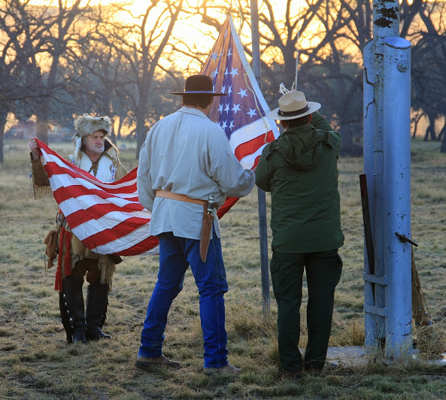

Frontiers Day IV
April 29-30, 2016
Camp Fawcett
Barksdale, TX

John Davis | Beto Torres Jr.
Booshway ClickClick | Segundo LK
(830) 965-5425 | (830) 900-4354
ironhorse1885@yahoo.com | humberto.torresjr@gmail.com

Who can participate at Frontiers Day IV?
All currently registered Boy Scouts, Venture, and Explorer Scouts are invited to participate. Frontiers Day IV can be physically, mentally, and emotionally demanding and each participant should be socially mature.
Individual Scouts and Units will be recognized for their exceptional demonstrations of skills learned. Scouts and Adults will also share in the culture of the mountain man.

What happens at Frontiers Day IV Camporee?
Scouts will compete and participate in the following events, however events are subject to change.
Action Archery | Two Man Saw
Black Powder | Wells Fargo
Knife Throwing | Dutch Oven Cooking
Tomahawk Throwing | Old Fashioned Root Beer
Caber & Cannonball Toss | Colter Run
Primitive Fire Starting | …and more

Registration & Cost
All participants will register through www.inteliscout.com. Payments can be made by cash, check, or credit. A late fee of $5 will be added to all participants who pay after April 4th.
Youth Fee: | $15.00 | Adult Fee: | $5.00


Updates and Latest Information
For updates, changes, and last-minute information please refer to www.swtxscouts.org Also please refer to our website for post camp articles, photos, and videos of Frontiers Day IV.

